**Assignment Day 5**

**Question 1:**

1. Add a 10GB disk to the CentOS.

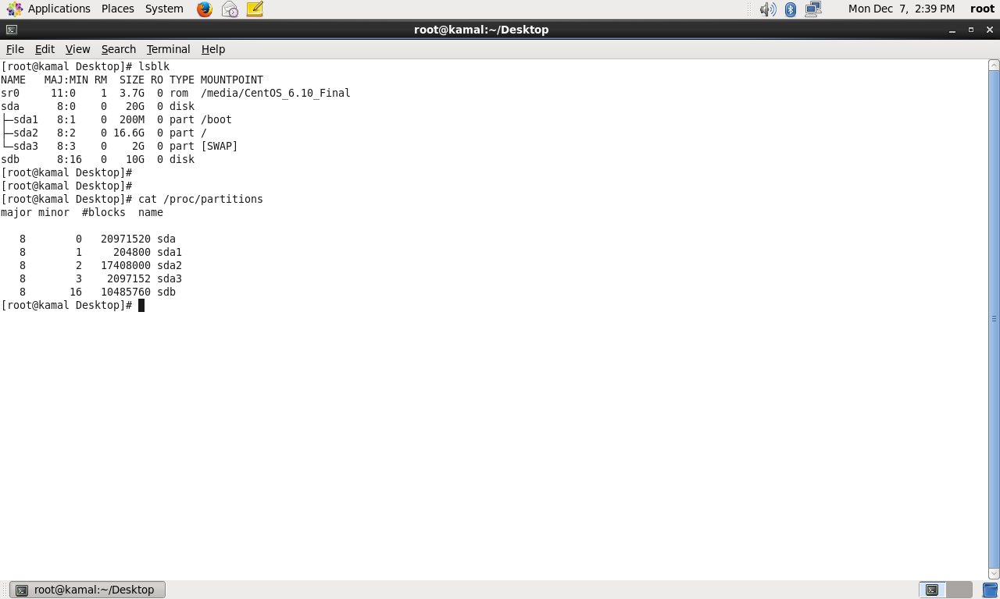

2. Create 2 Partitions 4GB and 6GB of Space respectively.

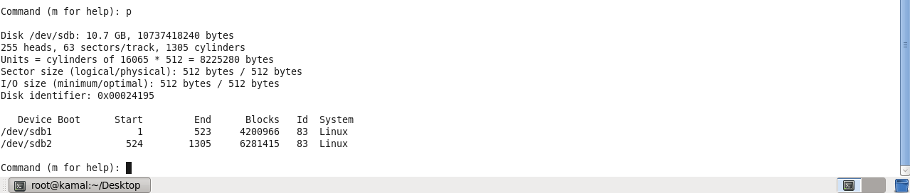

3. Format 4GB with xfs and 6GB with ext4 file system.

4. Mount 4GB and 6GB in /data and /music directory respectively.

5. Create one file of 1GB in each of the mount point created above.

6. Verify the disk Consumption and disk space free in the mounted partitions.

